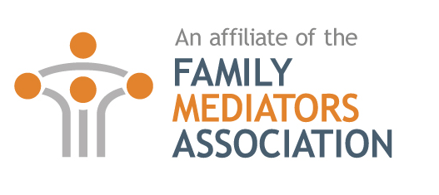
FMA Affiliate Member Application Form

The details you enter below will be held on record by FMA, and used to communicate with you. It is important that the information provided is accurate and clear.
Please update us if your contact details change during the year.
If you are already a full member of FMA you are entitled to free affiliate membership!

CONTACT DETAILS
Title: | First Name: |  |  |  |  | Last Name:
Organisation:
Full Postal Address:

Town/City: |  |  |  |  | County: |  | Post Code:
Contact Numbers: |  | Telephone: |  | Mobile:
Email Address:

PROFESSIONAL DETAILS
Affiliate Occupation:
Professional Qualifications:
What year did you complete this qualification?
List any membership organisation you are registered with regarding the above qualification?
You are consenting to appear on the FMA website in the following professional capacity/capacities |  |  | Accountant Contact supervisor Financial services Life/Personal coach Mortgage broker Social media and marketing expert Software specialist (including case management systems) Solicitor or direct access barrister – family specialist Therapist (registered) – adult, child, family, play Child consultant
Are you a full member of the FMA |  |  | Yes No
If you answered no, do you have a good understanding of the Family Mediation Profession? |  |  | Yes No
If you answered no, you will need to confirm here that you have read the information on the FMA website regarding the mediation process and that you have read the FMC Code of Conduct for family Mediators. |  |  |  |  | Yes No
DATA PROTECTION CONSENT
It is necessary to have your consent to hold the above information. By signing this form, you are giving that consent.
MEMBERSHIP RENEWAL
I confirm I have read and will subscribe as far as is relevant to the FMC Code of Practice. |  |  |  | Yes No
I am a full FMA member and wish to benefit from my free affiliate membership  OR  I wish to apply for annual affiliate membership with the Family Mediators Association (FMA) for the subscription period to 31 December 2025.  By signing this form you are agreeing that if you cease to be a member you will use your best endeavours to remove all references to FMA membership from all listings. |  |  |  | Signed |  |  |  | Date
AFFILIATE MEMBERSHIP FEE
Please pay by debit card if possible as this saves costs.
I enclose a cheque for £100 made payable to the FMA for the subscription year 2025
I require to be invoiced

I wish to pay by debit/credit card: (Amex not accepted)
Please debit my Access/Visa/MasterCard/Barclaycard with my membership fee of £100
Card No.

Expiry Date MM/YYYY: Start Date MM/YYYY: 3 Digit Security Code:

In order to let everyone know what it is you do and how you can help as an affiliate, in 100 words or less, please write a summary of your skills, and we will add it to the affiliates page alongside your contact details.

