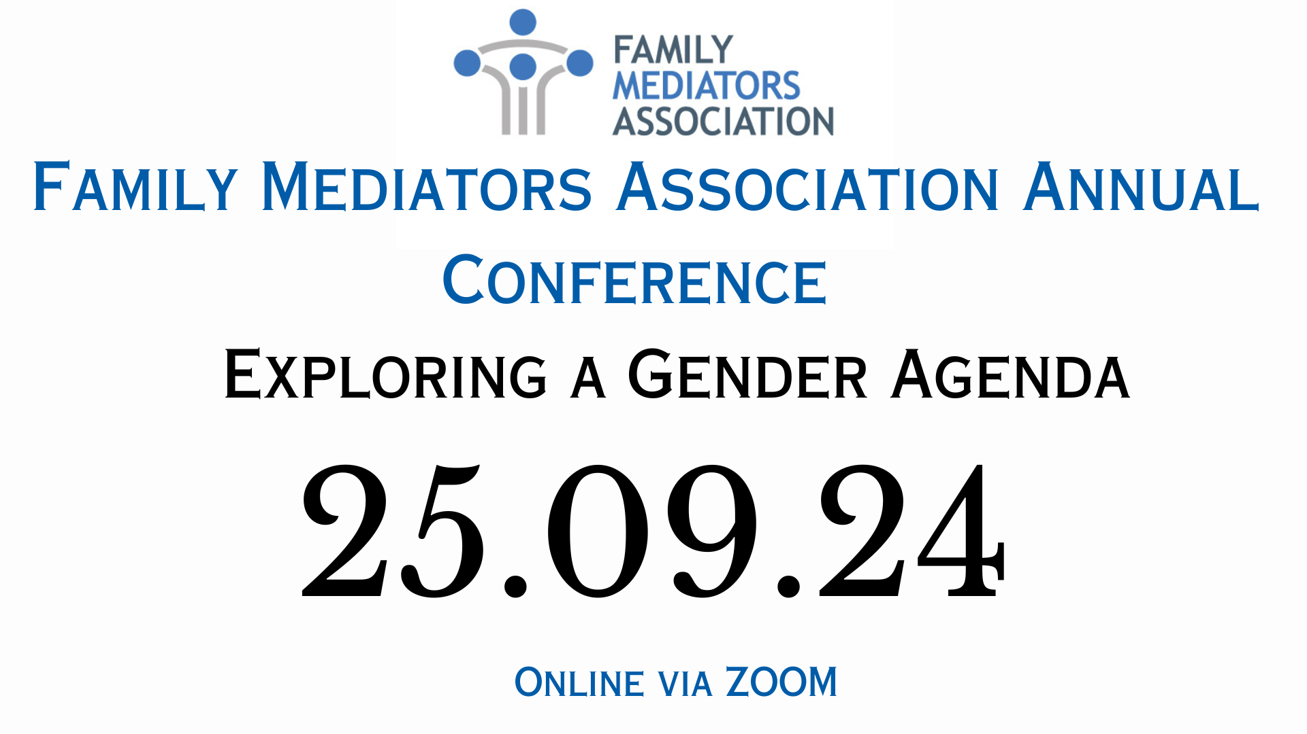

Please complete you details below:
Family Name: | First Name: | Title:
Company:
Address:

County: | Postcode:
Telephone: | Email:

REGISTRATION FEES | FMA MEMBER RATE |  | NON-MEMBER RATE
Standard Rates

Wednesday 29 September 2024 Registration | £120  £100 + £20 VAT |  | £190  £158 + £32 VAT
Payment must be received by close of early bird rate or invoice will be transferred to the standard rate.

*NB: Please ensure that your 2024 FMA membership dues have been paid. If your dues are not paid at time of registration, you will be charged the non-member delegate rate.

AGM
Are you attending the AGM on 24 September 2024? (Members only) Yes No

PAYMENT DETAILS FOR CONFERENCE REGISTRATION
CREDIT CARD PAYMENT. We do not accept AMEX.

Card No: / / /

Name on card

Expiry Date: MM/YYYY Start Date: MM/YYYY 3 Digit Security Code:
NB: This information will be destroyed after payment.
If you require an invoice from us, please complete this section:
Invoice name and address: (if different from above) |  | Purchase Order Number (if any):
E-mail: |  | Telephone:
I acknowledge and agree to the Terms & Conditions as stated below.

Participant’s Signature: Date:

NB: Please ensure that your 2024 FMA membership dues have been paid. If your dues are not paid at time of registration, you will be charged the non-member delegate rate.

TERMS AND CONDITIONS
Cancellation of Registration by Delegate - It is a condition of this booking that notification of cancellation received in writing by FMA Trading Ltd/Northern Networking Events Ltd prior to 1st July 2024will entitle the delegate to a refund of the pre-paid fees less an administration charge of £50. No refund will be made after 1 1st July 2024. If your cancellation is received after 1st July 2024, you will still be required to pay the full fee.

It is a condition of this booking that FMA Trading Ltd/Northern Networking Events Ltd and/or its Agents have the right for any reason beyond their control to alter or cancel, without prior notice, the Annual Conference or any of the arrangements, timetables, plans or other items relating directly or indirectly to the Annual Conference and that FMA Trading Ltd/Northern Networking Events Ltd and/or its Agents shall not, subject as after mentioned, be liable for any loss, damage, expenditure or any inconvenience caused as a result of such alteration or cancellation and in the event of cancellation of the Annual Conference the pre-paid delegate registration fees will be returned in full and FMA Trading Ltd/Northern Networking Events Ltd and/or its Agents shall not be liable for any loss, damage, expenditure or inconvenience caused as a result of such cancellation. Notice to cancel must be in writing.

