CRITERIA FOR FMA MEMBERSHIP CATEGORIES

Full Membership £200 1 January – 31 December 2024
To be considered for full membership with FMA in 2023 we require that:
- You should complete a continuing development record, demonstrating that you have maintained competency.
- You must have attended regular consultancy sessions with your PPC, a minimum of four hours a year, two of which must be face to face.
- You are a practising Family Mediator with a minimum of 15 mediation hours professional practise (cannot include MIAMs).
- You must have current Professional Indemnity Insurance to at least the recommended level of
- £1 million.
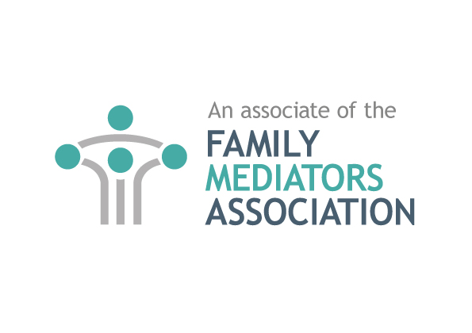
Practising Associate Membership £200 1 January – 31 December 2024
FMA appreciate that you may not have met the minimum requirements for full membership as laid out above. You could therefore still be considered for Associate Membership. You will be entitled to all the benefits of full membership with the exception of having the right to vote and inclusion on the FMC database. You can only remain a practicing associate member for a maximum of 3 years.
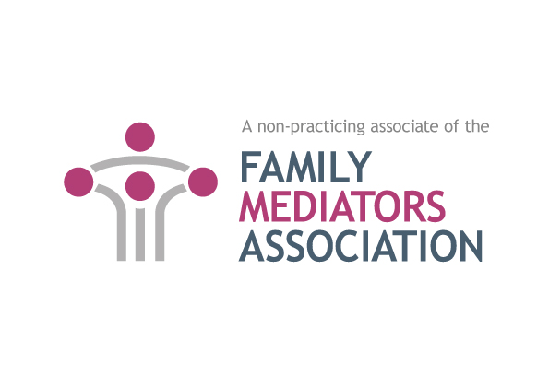
Non-Practising Associate Membership £75
If you are a non-practising mediator or are practising abroad having undertaken Foundation training and wish to remain connected with FMA, you may be considered for Non-Practising Associate Membership. A non-practising mediator should not hold themselves out to be a practising mediator in England and Wales. A non-practising mediator intending to return to practice must have been formally approved before carrying out any mediation and must apply in writing to convert to a practising associate member, providing a detailed PPC letter in support setting out all relevant circumstances. Refresher or transitional training is likely to be required, especially if you are returning from abroad.
N.B. Based on the answers you provide in your application form, the FMA administration office will confirm which membership category you qualify for.

The details you enter below will be held on record by FMA, and used to communicate with you. It is important that the information provided is accurate and clear.
Please update us if your contact details change during the year, or if you change your PPC. Failure to do so can result in termination of membership.
MEMBERSHIP TYPE
PLEASE SELECT THE TYPE OF MEMBERSHIP YOU ARE APPLYING FOR (see page 1 for membership types): |  |  | FMCA Unique Reference Number (URN)  Full Practising Associate Non-Practising Associate
CONTACT DETAILS
Title: | First Name: |  |  |  |  | Last Name:
Organisation:
Full Postal Address:

Town/City: |  |  |  | County: |  |  | Post Code:
Telephone: |  |  |  |  | Mobile:
Email Address:

Name of PPC: |  |  |  |  | PPC email address:
If your contact details are to differ from those displayed on the website, please contact the administration office by email (info@thefma.co.uk)
PROFESSIONAL DETAILS AND QUALIFICATIONS
Your Professional Background:
Legal Therapeutic Business Education Other
Year completed Family Mediation Foundation Training: |  |  | Name of training organisation:
CHILD INCLUSIVE MEDIATION - FORMERLY DIRECT CONSULTATION WITH CHILDREN (DCC)
Are you a trained CIM Yes No  Have you attended a CIM update day Yes No |  |  |  |  | Year of Training (CIM):
 |  |  |  |  | Organisation you trained with (CIM):
THE LEGAL AID AGENCY
Are you currently working with a service which offers legal aid mediation? Yes No

CONTINUED LEARNING AND PROFESSIONAL DEVELOPMENT (CPD)
I confirm that I have undertaken appropriate CPD training in 2023 Yes No

MEDIATION HOURS (This does not include MIAMs)
In 2024 will you be a practising Mediator? Yes No
I confirm that I have completed a minimum of 15 hours in 2023. Yes No
SUPERVISION HOURS
I confirm that I have undertaken a minimum of 4 hours with a PPC in 2023. Yes No
PROFESSIONAL INDEMNITY INSURANCE
I confirm I have Professional Indemnity Insurance to at least the recommended level of £1 million:
This is a condition of FMA membership. Your membership will not be approved without it. Yes No

DATA PROTECTION CONSENT
Under the new GDPR Data Protection Act, it is necessary to have your consent to hold the above information as per our privacy policy which can be viewed on the FMA Website www.thefma.co.uk
By signing this form, you are giving that consent. N.B. The information provided upon application will be held securely in our administration office.
MEMBERSHIP APPLICATION
I confirm I comply with the FMA and FMC Code of Practice and work within the FMA Agreement to Mediate and consent to sharing the information supplied with the FMC Yes No

Are you currently an active practicing family lawyer Yes No

Can you Help?
Do you have the capacity to provide observation of your mediation and or co mediation to assist a member to comply with Accreditation? Yes No

Are you a member of another mediation organisation other than the FMC? Yes No

If yes which one

PPC CONFIRMATION IN SUPPORT OF MEMBERS APPLICATION
TO BE COMPLETED ONLY IF YOU ARE A PPC
We encourage all our PPC’s to undertake an annual PPC Update course.
Are you an FMA trained PPC?  Yes No |  | If no, please state name of organisation you trained with: |  | Year of Training:
PPC CPD/Continuous Learning and Development in 2023
(FMA Recommends all PPCs to undertake an update in theory practice course every year Please only complete this section if you are a PPC)
I consent to FMA sharing the information supplied above with the FMA PPC Co-ordinators, to enable co-ordination of the PPC networks. |  |  | Signed |  | Date
I confirm I have met the minimum 5 hours PPC CPD training in 2023 Yes No
Date: | Course: |  | Provider/Event (5 Hours): |  | CPD Points:  (if applicable)

MEMBERSHIP PAYMENT
Full membership and Practising associate membership from 1 January-31 December 2024 £200, Non-practising associate membership £75.
Please pay by debit card if possible as this saves costs.
I wish to make payment for the subscription from 1st of current month to 31st December 2023.

I wish to pay by debit/credit card: (Amex not accepted)
Please debit my Access/Visa/MasterCard/Barclaycard with my membership fee of £
Card No.
Expiry Date MM/YYYY: Start Date MM/YYYY: 3 Digit Security Code:
I enclose a cheque for £ made payable to the FMA
I require to be invoiced to pay later by Bacs transfer
By making this payment I confirm that if I cease to be a member I will use my best endeavours to remove any reference to FMA membership in my public profiles

Confirmation will be sent once payment has cleared and a certificate and receipt will follow once PPC approval has been received (as well as payment).
Membership is not valid until both payment and PPC approval are received and you have been awarded your certificate.

IMPORTANT NOTICE TO ALL MEMBERS
Please note that your membership renewal is not valid until your PPC has approved the information provided and we have received full payment of your membership. It is your responsibility to seek approval from your PPC
PPC CONFIRMATION IN SUPPORT OF MEMBERS APPLICATION FOR RENEWAL
To be completed by the members PPC
I confirm that:-
- I am the above FMA Member’s current PPC and confirm as far as I can that the Member has undertaken the required learning and development, received the required supervision and undertaken the required number of mediation hours.
- The member has agreed that the FMA may contact me directly if there are any queries or outstanding information required.
- I am a registered PCC and current member of FMA/Resolution/Law Society/NFM/ The College of Mediators (delete as appropriate)
- I consent to the FMA confirming my up to date current PPC Registration and membership with my above mentioned FMC Member Organisation.
- I confirm that I have read FMA’s complaints and disciplinary procedure and also FMA’s recommended best practice for members’ mediation complaints procedure and that I agree to abide by the procedures in the event of any complaint against the Member.
Print Name:
Print Address:

Email:

Signed: |  | Dated:

